NATIONAL UNIVERSITY OF SCIENCES & TECHNOLOGY


Degree: MS-Bioinformatics
Department: School of Interdisciplinary Engineering & Sciences (SINES)
Submitted to: Dr. Zamir Hussain
Assignment No: 02
Student name: Mahreen Nawaz
Registration No. 533241
Subject: Mathematic for Bioinformatics
Topic: From preprocessing to building simple and multiple linear regression models using CRD Score as the dependent variable.
Submission Date: 17 November 2025

Objectives:
- Preprocess the data
- Simple linear regression
- Multiple Linear regression
1. Preprocessing the data:
- As the column BP was recorded as 70/130, so I preprocessed the column and separated it into two different columns as Diastolic BP (DBP)=70 and Systolic BP (SBP)=130 in excel.
- The dependent variable CVD Risk had some missing values; I deleted the entire rows as imputing the missing values for dependent variables can affect the estimates of regression coefficients and their standard errors potentially leading to biased results.
- There was total 8 missing values in dependent variables CVD risk. I selected the column CVD risk press ctrl+f opening the finding dialogue box where I type the (*) and click on find next and deleted those rows having missing values.
- The sample size was 1305 after deletion of 8 rows it is 1297.
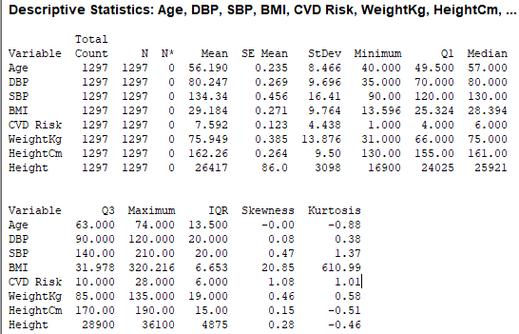
Figure 1 Descriptive statistics of the data

Detecting and removing outliers:
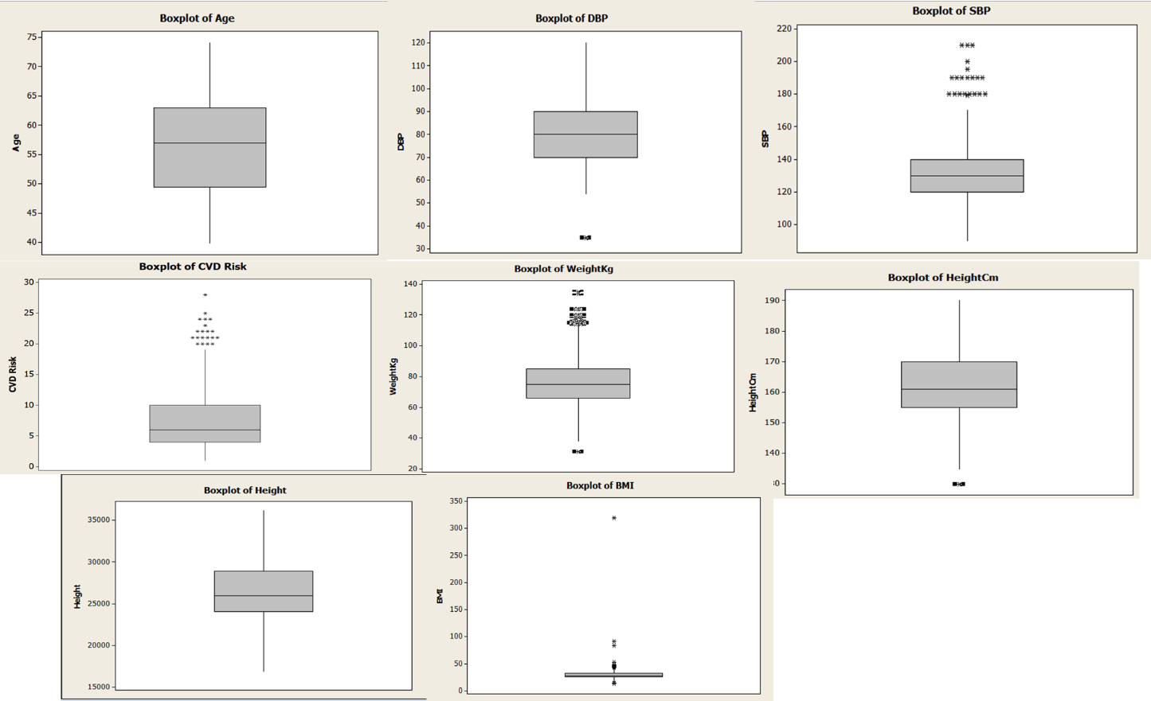
Figure 2 Boxplot of all the variables
There are outliers in DBP, SBP CVD risk, weight in kg BMI and height in cm.
Formal way of detecting and removing outliers:
Z-scores were computed for all continuous variables (DBP, SBP, BMI, CVD Risk, Weight, Height)
Minitab:
- Go to Calc → Calculator
- In Store result in, enter the new column name (e.g., Z_DBP)
- Repeat for all variables to generate Z-score columns.
Identified outliers using the Z-score rule:
- Observations with |Z| > 3 were defined as outliers.
- This threshold is the standard statistical criterion for extreme deviations.
Created a cleaned dataset using Subset Worksheet in Minitab:
- Go to Data → Subset Worksheet
- Select Include rows that match
- Enter the condition to retain only non-outlier values, is given below
ABS(Z_DBP) <= 3 AND
ABS(Z_SBP) <= 3 AND
ABS(Z_BMI) <= 3 AND
ABS('Z_CVD risk') <= 3 AND
ABS(Z_weight) <= 3 AND
ABS(Z_heightCm) <= 3
Choose a name for the new worksheet (e.g., Cleaned data)
- Click OK to generate the cleaned dataset.
Excluded all rows flagged as outliers through the condition above, ensuring only values within ±3 standard deviations were retained.
I performed all statistical analyses and regression modeling on the cleaned dataset, ensuring that extreme values did not distort model estimates or interpretation.
Encoding the categorical variable:
We don’t need to manually encode the categorical variables because Minitab will automatically create dummy variables during regression.
Checking normality of CVD Risk:
Minitab steps:
- Graph → Probability Plot → Single
- Select CRD Score
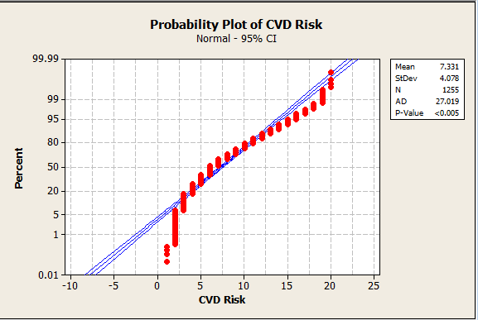
Figure 3 PP plot of CVD risk
As the distribution is not normal but considering the central limit theorem our sample size is greater than 30 so we assume that the distribution is normal.

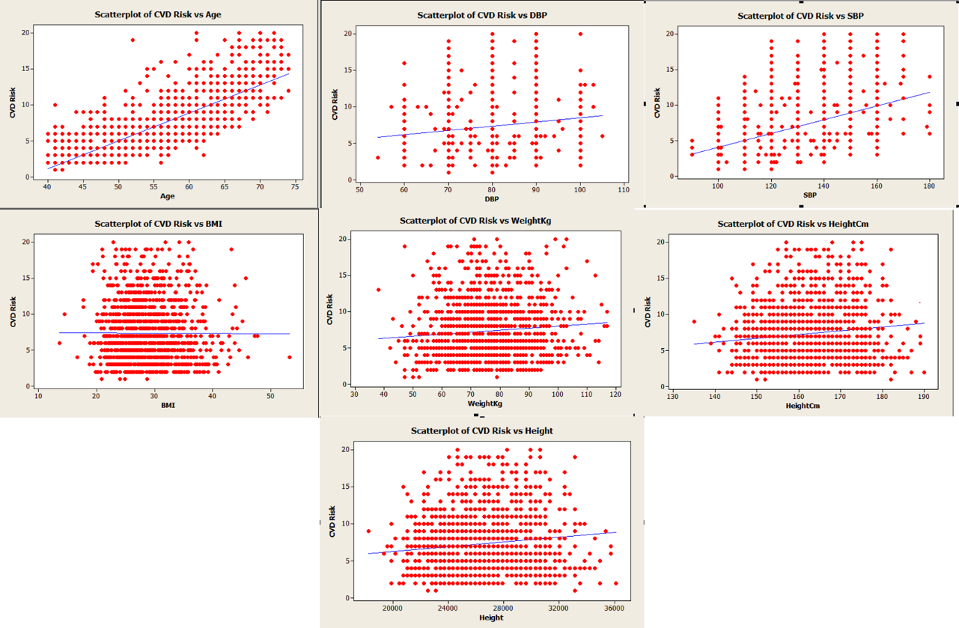
Figure 4 Scatter plot of all variables with CVD risk
2. Simple linear regression:
Selection of Predictor Variables for Simple Linear Regression
- Scatterplots were examined to evaluate the linear relationship between CVD Risk (dependent variable) and each continuous predictor.
Simple linear regression requires a reasonably linear trend between the variables.
- Age demonstrated a clear positive linear relationship with CVD Risk.
The scatterplot showed an upward trend where CVD Risk increases as Age increases.
→ Age was selected as the primary predictor for simple linear regression.
- SBP (Systolic Blood Pressure) showed a weak but positive linear trend.
Although the relationship was not strong, the overall pattern still showed increasing CVD Risk with rising SBP.
→ SBP was considered as a secondary acceptable predictor.
- BMI, DBP, Weight, and Height did not show any meaningful linear relationship with CVD Risk.
Their scatterplots displayed large variability, flat regression lines, and no consistent direction.
→ These variables were not used for simple linear regression due to absence of linearity.
- Based on visual inspection and linearity assessment, Age was identified as the most appropriate variable for building a simple linear regression model to predict CVD Risk.

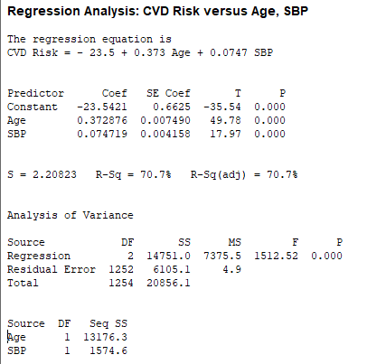
Figure 5 Simple linear regression model stats.
1.Regression Model Overview
A multiple linear regression was performed to examine the combined effect of Age and Systolic Blood Pressure (SBP) on CVD Risk.
The fitted regression equation was:
$$\text{CVD Risk}=-23.5+0.373×\text{Age}+0.0747×\text{SBP}$$
This equation shows how CVD Risk changes with Age and SBP when both variables are included in the model.
2. Interpretation of Coefficients
Intercept (Constant = –23.5421)
- Represents the predicted CVD Risk when Age = 0 and SBP = 0.
- Although not meaningful clinically, it is required for the model.
ge (Coef = 0.372876, p < 0.001)
- Age has a statistically significant positive effect on CVD Risk.
- For every 1-year increase in Age, the CVD Risk increases by 0.373 units, holding SBP constant.
- The extremely small p-value (<0.001) indicates strong evidence that Age is a meaningful predictor.
SBP (Coef = 0.074719, p < 0.001)
- SBP also has a statistically significant positive effect on CVD Risk.
- For every 1 mmHg increase in SBP, CVD Risk increases by 0.0747 units, controlling for Age.
- Again, p < 0.001 indicates the effect is statistically significant.
3. Model Fit Statistics
R² = 70.7%
- The model explains 70.7% of the variability in CVD Risk.
- This indicates very good model fit, meaning Age and SBP together are strong predictors.
Adjusted R² = 70.7%
- Adjusted R² matches R² because the model has only two predictors and both are significant.
- Confirm that the model is not overfitting.
Standard Error (S) = 2.20823
- On average, the predicted CVD Risk values differ from actual values by about 2.21 units.
⭐ 4. ANOVA (Model Significance)
Overall Regression Test: F(2, 1252) = 1512.52, p < 0.001
- The overall regression model is statistically significant.
- This means Age and SBP together significantly predict CVD Risk.
Sequential Sums of Squares
- Age (SS = 13176.3) contributes the largest share of explained variance.
- SBP (SS = 1574.6) still contributes but much less than Age.
This shows that Age is the dominant predictor, but SBP adds extra predictive power.
5. Final Interpretation:
A multiple linear regression model was fitted to assess the effect of Age and Systolic Blood Pressure (SBP) on CVD Risk. The model was statistically significant (F = 1512.52, p < 0.001) and explained 70.7% of the variance (R² = 70.7%). Both Age (b = 0.3729, p < 0.001) and SBP (b = 0.0747, p < 0.001) were significant positive predictors of CVD Risk. Specifically, CVD Risk increased by 0.373 units for each year increase in Age, and by 0.0747 units for each mmHg increase in SBP. These findings indicate that CVD Risk rises substantially with increasing age and systolic blood pressure.
3.Multiple linear regression:
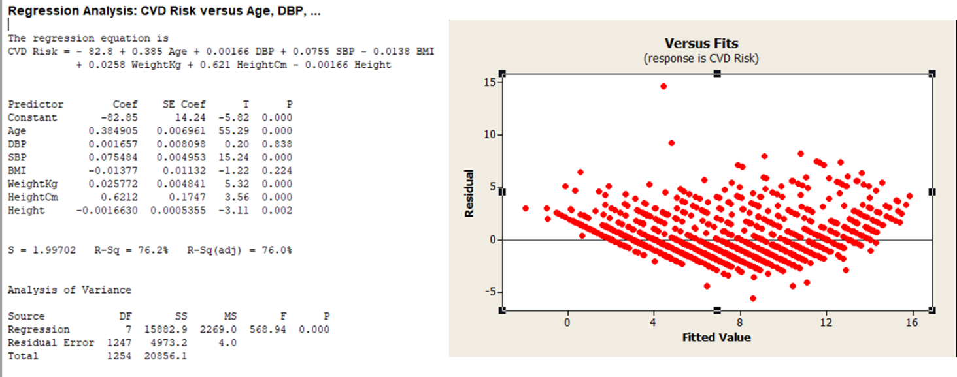
Figure 6 Multiple linear regression model stats.
1. Purpose of the Model
A multiple linear regression model was fitted to identify the combined effect of Age, DBP, SBP, BMI, Weight, HeightCm, and Height on CVD Risk.
2. Regression Equation
$$\text{CVD Risk}=-82.8+0.385\text{Age}+0.00166\text{DBP}+0.0755\text{SBP}-0.0138\text{BMI}+0.0258\text{Weight}+0.621\text{HeightCm}-0.00166\text{Height}$$
This equation shows how each variable affects CVD Risk when all other variables are held constant.
3. Interpretation of Coefficients
Age (β = 0.385, p < 0.001) – Significant
- For each 1-year increase, CVD Risk increases by 0.385 units, holding other variables constant.
- Strongest predictor in the model.
SBP (β = 0.0755, p < 0.001) – Significant
- Each 1 mmHg increase in SBP increases CVD Risk by 0.0755 units.
- Important cardiovascular predictor.
Weight (β = 0.0258, p < 0.001) – Significant
- Higher weight is associated with slightly higher CVD risk.
HeightCm (β = 0.621, p = 0.002) – Significant
- People with greater height in cm tend to show higher CVD risk.
(This may relate to measurement scaling; interpretation should be cautious.)
DBP (β = 0.00166, p = 0.838) – Not significant
BMI (β = −0.01378, p = 0.112) – Not significant
Height (raw height variable, p = 0.002)
- The Height variable is significant, but note: Height and HeightCm are highly collinear.
4. Model Fit Statistics
R² = 76.2%
- The model explains 76.2% of the variation in CVD Risk.
- Indicates strong predictive ability.
Adjusted R² = 76.0%
- Very close to R², meaning the model is not overfitted.
S = 1.997
- On average, predictions differ from actual CVD Risk by about 2 units.
Model ANOVA
- F = 568.94, p < 0.001
→ The overall model is highly significant.
5. Diagnostics – Residuals vs Fits Plot
Residuals plot shows:
Pattern Visible (Not Random)
Residuals form a curved “smile” or funnel shape.
Interpretation:
- Indicates heteroscedasticity (non-constant variance).
- Variance increases at higher fitted values.
- Also suggested non-linearity is present.
6. SUMMARY PARAGRAPH
A multiple linear regression analysis was conducted to assess the influence of demographic and physiological factors on CVD Risk. The overall model was statistically significant (F = 568.94, p < 0.001) and explained 76.2% of the variance in CVD Risk (R² = 76.2%; Adjusted R² = 76.0%). Age (β = 0.385, p < 0.001), SBP (β = 0.0755, p < 0.001), Weight (β = 0.0258, p < 0.001), HeightCm (β = 0.621, p = 0.002), and Height (p = 0.002) were significant predictors of CVD Risk. DBP and BMI were not statistically significant. The residuals-versus-fits plot showed a curved pattern, suggesting non-constant variance and potential non-linearity, indicating that assumptions of linear regression were not fully met. Despite this, Age and SBP remained strong predictors of CVD Risk.

